Domains:

Types 🡪 stream & datagram:

Reliable delivery 🡪 you need to know it is delivered

In datagram, when connection is opened from the server, any client can dump their message.

stream 🡪 ev telefon line’ı gibi. client ve server 1 hattı paylaşır ve karşı karşıyalar.

datagram 🡪 birden fazla client hattına data gönderebilir.

Socket system calls:

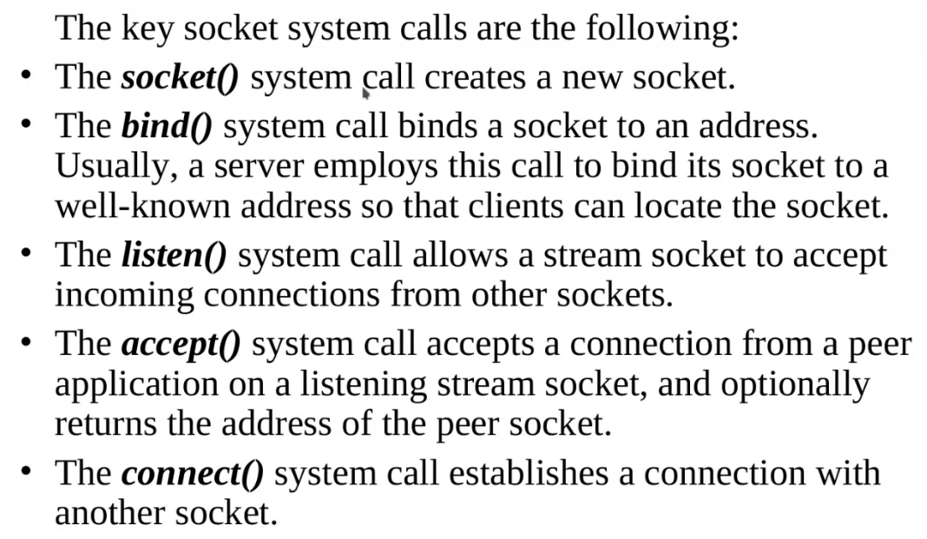

accept 🡪 blocks the process until the first connection is made.

connect 🡪 done by client side

For both receive and send, you can use same fd.

Stream sockets:

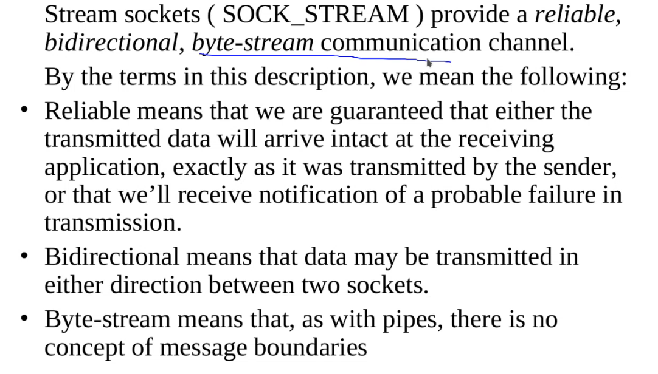

Datagram sockets:

Zarfa mesajı koyup adresi verip göndermek gibi. Yolladıktan sonra emin olmak istemiyorsan beklemek zorunda değilsin.

Mesajın boyu önemli değil. Her gönderdiğin mesaj aynı boyda olmak zorunda değil. Gönderdiğinden emin olmak istiyorsun. 🡪 STREAM

Birden fazla clientın aynı servera ulaşmasını ve datayı dump etmesini istiyorsun. 🡪 DATAGRAM

STREAM 🡪 TCP

DATAGRAM 🡪 UDP

SUMMARY

DATAGRAM 🡪 FIX SIZE